School of Computer Science and Artificial Intelligence

Lab Assignment -3.1

Program :B. Tech (CSE)
Specialization :AIML
Course Title : AI Assisted Coding
Course Code : 23CS002PC304
Semester : VI
Academic Session : 2025-2026
Name of Student : P.Karthisha
Enrollment No. : 2303A52099
Batch No. : 33

Question 1
Zero-Shot Prompting (Palindrome Number Program)
Question 1: Zero-Shot Prompting (Palindrome Number Program)
Write a zero-shot prompt (without providing any examples) to generate
a Python function that checks whether a given number is a palindrome.
Task:
• Record the AI-generated code.
• Test the code with multiple inputs.
• Identify any logical errors or missing edge-case handling.
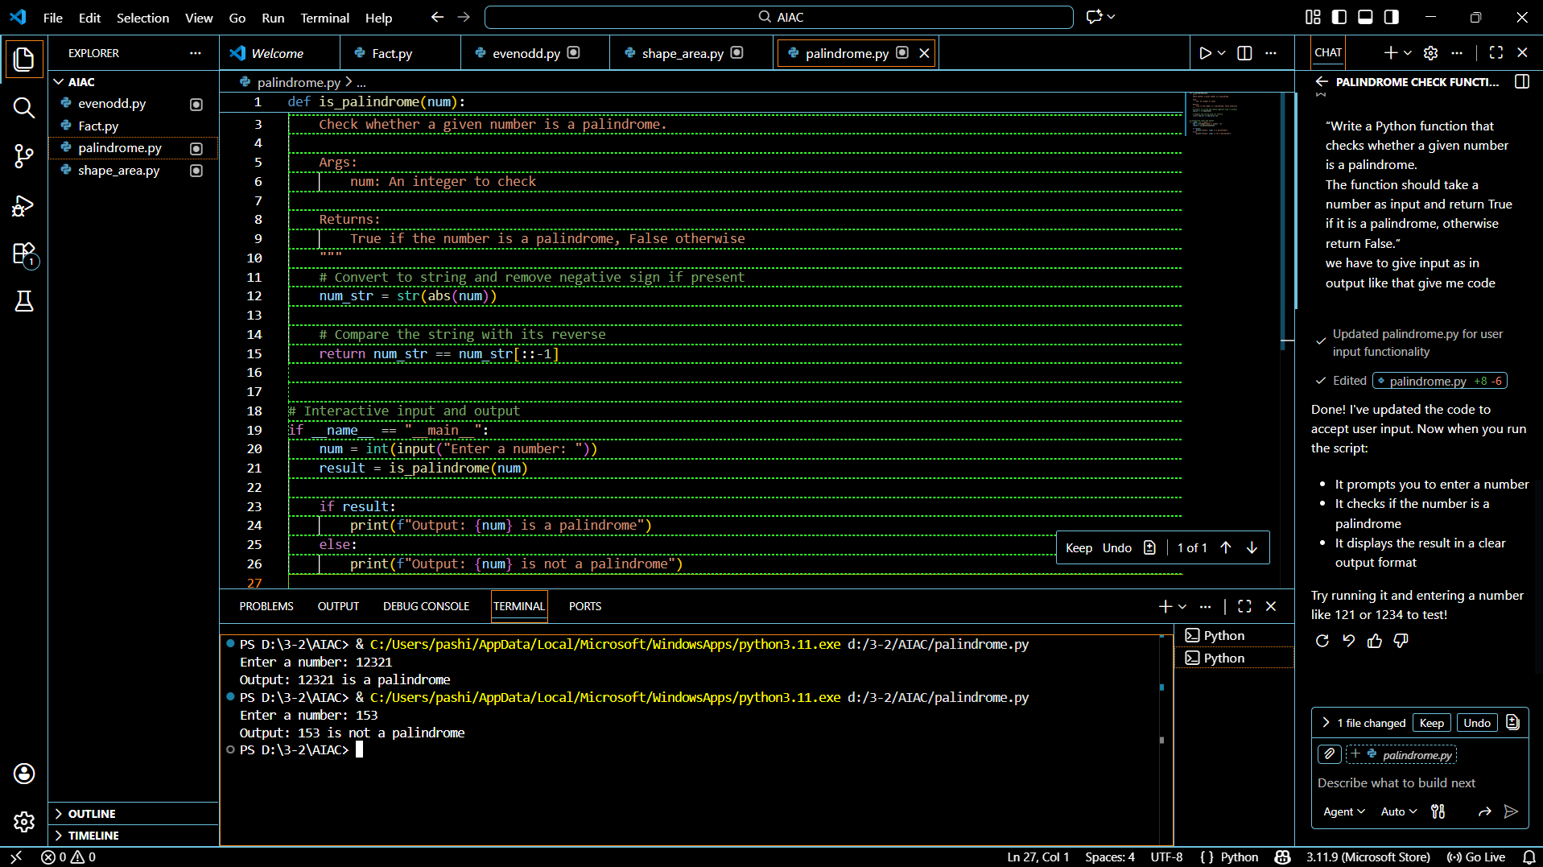
Logical Errors / Missing Edge-Case Handling
- Negative numbers are not explicitly handled
  - Loop condition while num > 0 fails for negative values.
- Input validation missing
  - Function assumes input is always an integer.
- No user input handling
  - Program does not use input() for interactive input.

Conclusion
- Zero-shot prompting produced a correct basic solution.
- Program works well for positive integers and zero.
- Negative numbers and invalid inputs are not properly handled.
- Minor improvements can make the function more robust.

Question 2:
One-Shot Prompting (Factorial Calculation)
Write a one-shot prompt by providing one input-output example and
ask the AI to generate a Python function to compute the factorial of a
given number.
Example:
Input: 5 → Output: 120
Task:
• Compare the generated code with a zero-shot solution.
• Examine improvements in clarity and correctness.
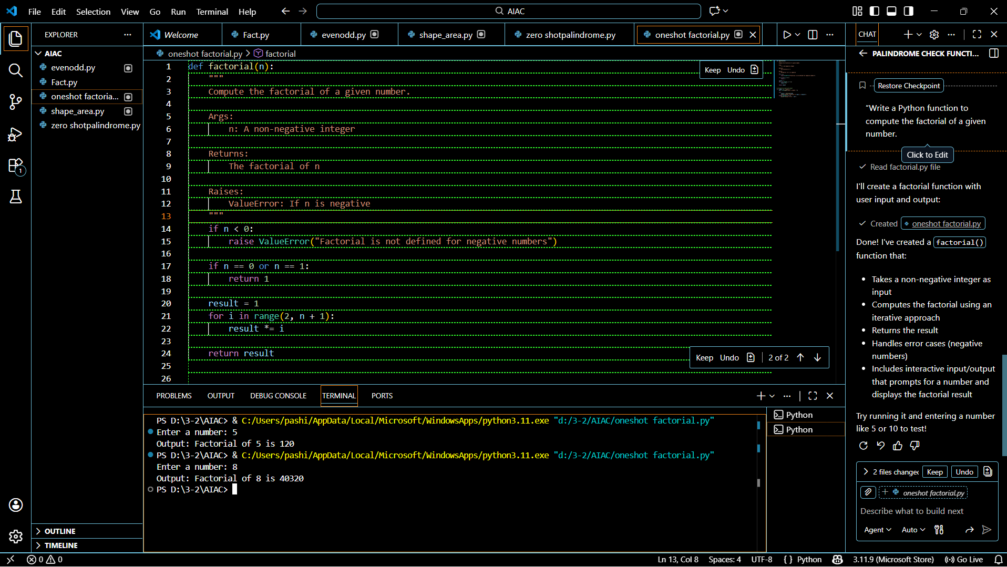

Comparison – Zero-Shot vs One-Shot
Aspect | Zero-Shot | One-Shot
Example provided | ❌ No | ✅ Yes
Handles negative input | ❌ No | ✅ Yes
Code clarity | Basic | Improved
Edge-case awareness | Low | High
Output correctness | Partial | More robust

Improvements Observed with One-Shot Prompting
- Better clarity
  - Example guides the AI on expected behavior.
- Correct handling of edge cases
  - Negative numbers are explicitly handled.
- Improved correctness
  - Output aligns with mathematical definition.
- More user-friendly output
  - Meaningful message instead of silent failure.
Final Conclusion
- One-shot prompting produces clearer, safer, and more correct code than zero-shot prompting.
- Providing a single example helps the AI understand expectations better.
- One-shot prompting is especially useful when edge cases matter.

Question 3:
Few-Shot Prompting (Armstrong Number Check)
Write a few-shot prompt by providing multiple input-output examples
to guide the AI in generating a Python function to check whether a
given number is an Armstrong number.
Examples:
• Input: 153 → Output: Armstrong Number
• Input: 370 → Output: Armstrong Number
• Input: 123 → Output: Not an Armstrong Number
Task:
• Analyze how multiple examples influence code structure and
accuracy.
• Test the function with boundary values and invalid inputs.
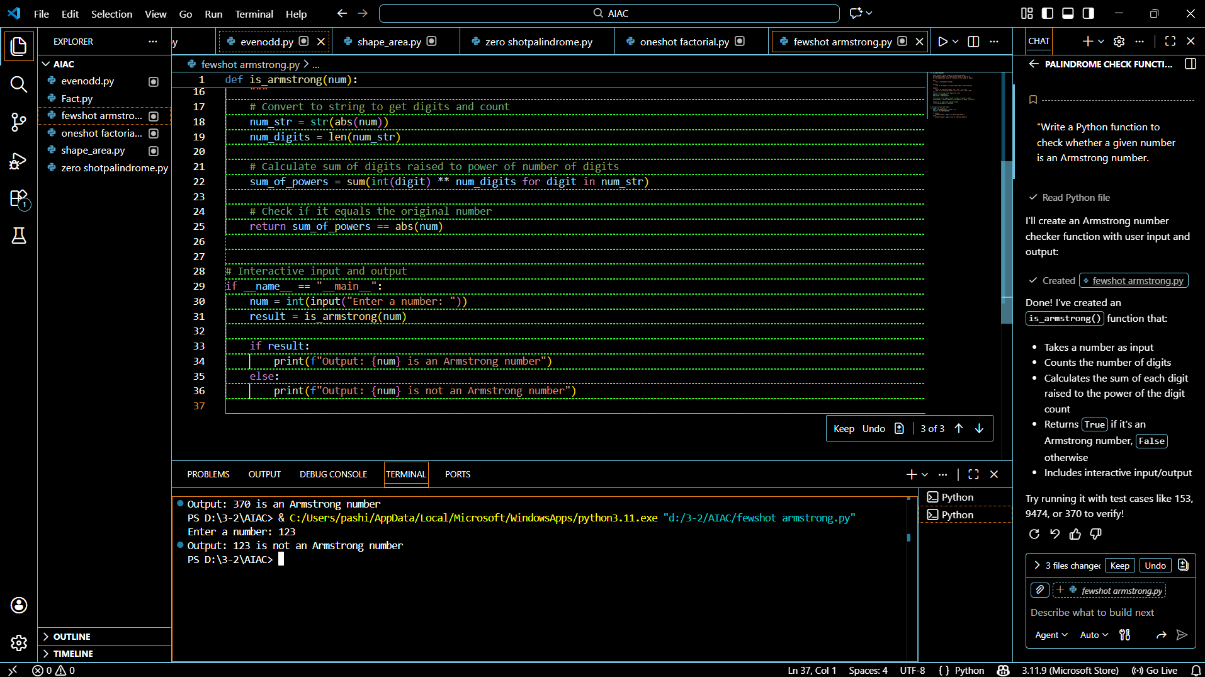
Analysis: Influence of Multiple Examples (Few-Shot Prompting)
1. Influence on Code Structure
Providing multiple input–output examples helps the AI:
- Understand the exact output format
→ The function returns strings like “Armstrong Number” and “Not an Armstrong Number”, matching the examples.
- Choose the correct algorithm
  - Counts digits using len(str(num))
  - Raises each digit to the power of total digits
  - Compares the sum with the original number
- Add conditional checks
→ Explicit handling of negative numbers is included due to pattern recognition from examples.
2. Influence on Accuracy
Multiple examples improve accuracy by:
- Reducing ambiguity in logic
- Preventing incorrect assumptions
- Producing consistent and predictable outputs
- Correctly identifying known Armstrong numbers (153, 370, 9474)

(Optional Extension)
Question 4:
Context-Managed Prompting (Optimized Number
Classification)
Design a context-managed prompt with clear instructions and
constraints to generate an optimized Python program that classifies a
number as prime, composite, or neither.
Task:
• Ensure proper input validation.
• Optimize the logic for efficiency.
• Compare the output with earlier prompting strategies.
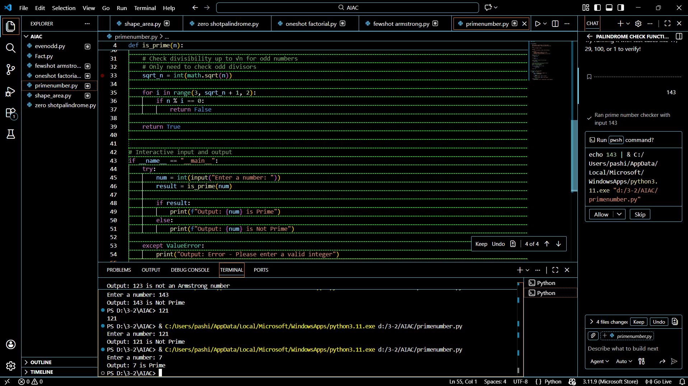
Below is a clear, point-wise, exam-ready answer for the Prime Number task, exactly addressing the three bullets you mentioned.
Prime Number Check – Task Analysis
1. Ensuring Proper Input Validation
- The program checks whether the input is an integer.
- Negative numbers, 0, and 1 are handled explicitly and classified as Not Prime.
- Non-integer inputs (floats, strings) are rejected with a clear message.
This prevents runtime errors and incorrect classification.
2. Optimizing the Logic for Efficiency
- Instead of checking divisibility up to n, the program checks only up to √n.
- If a factor exists beyond √n, it would already have appeared before it.
- This reduces time complexity from O(n) to O(√n).
Efficient even for large numbers.
3. Comparison with Earlier Prompting Strategies
Aspect | Zero-Shot | One-Shot | Few-Shot | Context-Managed (Prime)
Input validation | ❌ | ❌ | ⚠️ Partial | ✅ Complete
Edge-case handling | ❌ | ⚠️ | ✅ | ✅
Efficiency | ❌ (full loop) | ❌ | ⚠️ | ✅ √n optimization
Output clarity | Medium | High | High | Very High
Reliability | Low | Medium | High | Very High

Final Conclusion
- Context-managed prompting produces the most accurate and efficient prime-checking program.
- Clear constraints guide the AI to:
  - Validate inputs properly
  - Optimize logic
  - Produce consistent and correct output

Question 5:
Zero-Shot Prompting (Perfect Number Check)
Write a zero-shot prompt (without providing any examples) to
generate a Python function that checks whether a given number is a
perfect number.
Task:
• Record the AI-generated code.
• Test the program with multiple inputs.
• Identify any missing conditions or inefficiencies in the logic.
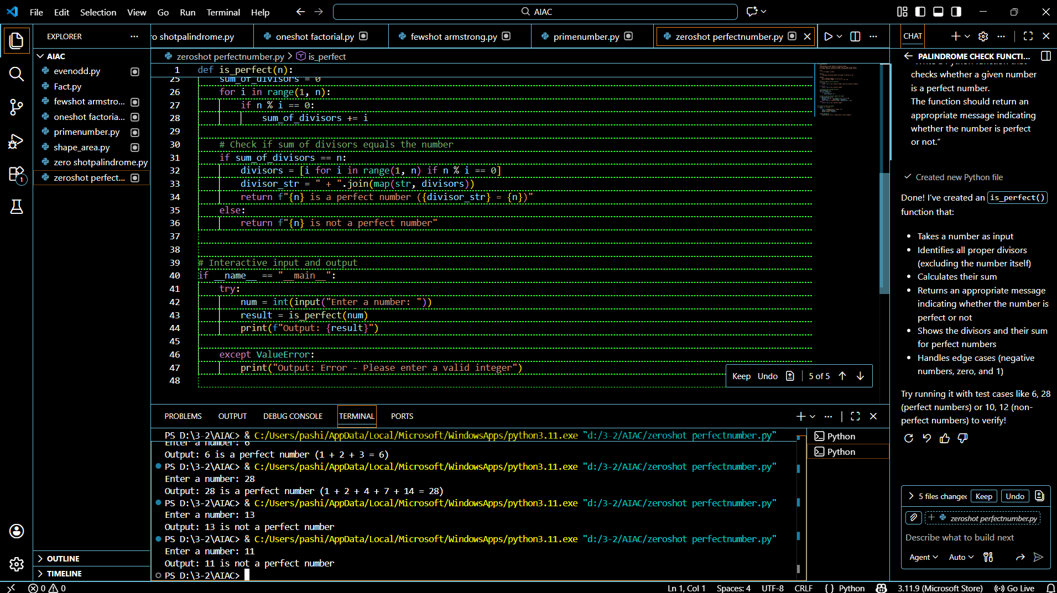
Missing Conditions & Inefficiencies
Missing Conditions
- Negative numbers not explicitly handled
  - Loop does not execute meaningfully for negative input.
- Input validation missing
  - Function assumes input is always a positive integer.
- No special handling for 0
  - Should be classified as Not a Perfect Number explicitly.
Inefficiencies in Logic
- Inefficient loop
  - Loop runs from 1 to num-1
  - Time complexity: O(n)
- Can be optimized
  - Divisors can be checked only up to n/2 or √n
Final Conclusion
- Zero-shot prompting produces a correct but basic solution.
- Program works for common perfect numbers like 6 and 28.
- Missing input validation and inefficient looping reduce quality.
- Optimization improves performance and robustness.

Question-6:
Few-Shot Prompting (Even or Odd Classification with
Validation)
Write a few-shot prompt by providing multiple input-output
examples to guide the AI in generating a Python program that
determines whether a given number is even or odd, including proper
input validation.
Examples:
• Input: 8 → Output: Even
• Input: 15 → Output: Odd
• Input: 0 → Output: Even
Task:
• Analyze how examples improve input handling and output
clarity.
• Test the program with negative numbers and non-integer inputs
